**Australia’s Labour Force**

* Steady growth in the real wage rate since the late-1960s.
* Slow growth in the real wage from mid-1970s until the early-2000s.
* A widening real wage gap between skilled and skilled workers --- cause income in Australia to become more dispersed --- increase of inequality.
* A rising participation rate in the labour market.
* A relatively low unemployment rate in the 2000s compared to some EU countries.
* Over the last 5 years Australia’s nominal wage growth has slowed to the lowest level on records. (Partially due to low inflation)

**The labour Market**

* The perfectly competitive model of labour market:

1. Supply and demand analysis can be used to analyse the market for labour.
2. Demand for labour comes from employers for use in the production of goods and services.
3. Supply of labour comes from people who work for pay.
4. The price of labour is determined by the wage rate per unit of time.

* Wages and the demand for labour:

1. Each firm will decide how much labour to hire to maximise profits.
2. A worker is hired if the benefit of hiring an additional work >= cost of hiring that worker.
3. The marginal cost of hiring (MC) is the wage that has to be paid to that worker.
4. The marginal benefit (MB) is the value of that worker’s marginal product (VMP).

* The demand curve for labour:

1. Diminishing returns to labour:

If the amount of capital and other inputs in use is held constant, then the greater the quantity of labour already employed, the less each additional worker adds to the production.

1. The demand curve for labour is downward sloping. The higher the wage, the fewer workers employers will hire.
2. Shifts in the demand curve for labour occur for anything that changes the VMP. For example:

* A rise or fall in the relative price of the good.
* A rise or fall in labour productivity – the marginal product of labour (MPL) – for any level of employment.
* The demand for labour is based on whether the marginal benefit of a worker (“marginal product”) exceeds their marginal cost (real wage).

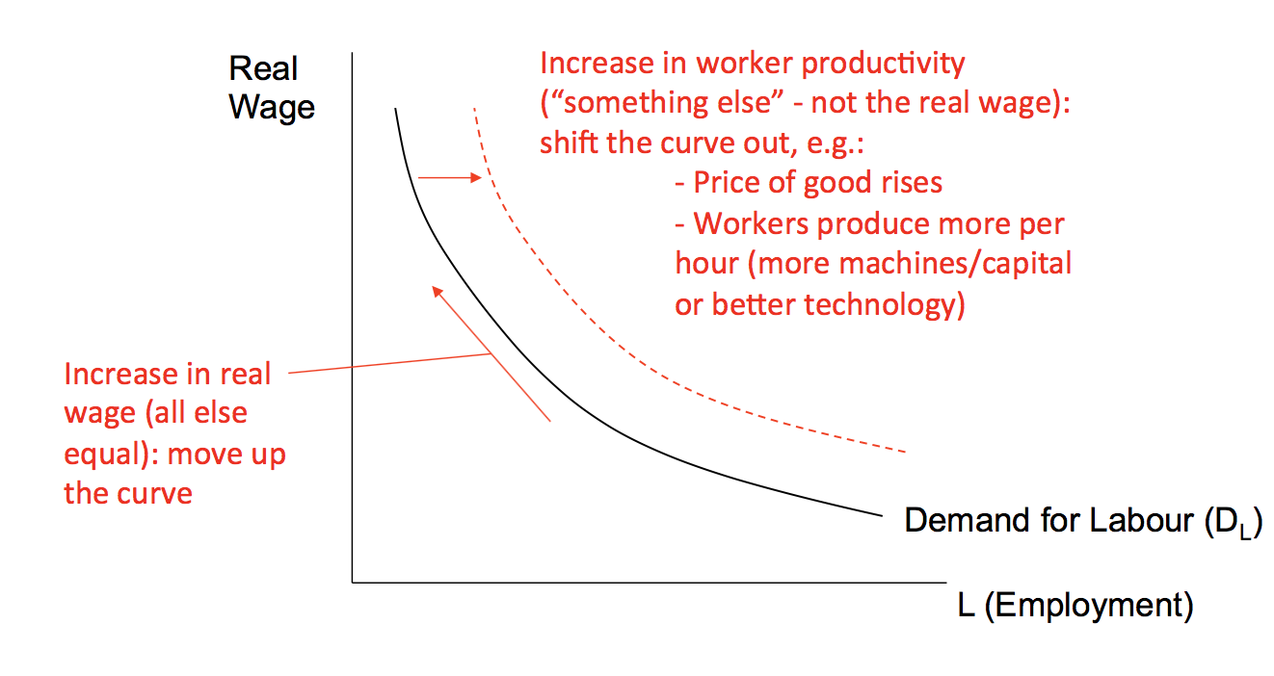

* The supply of labour:

1. Your reservation price of working is the minimum payment that you would accept to work rather than your next best alternative.
2. Although a little work might be fun, income is the main point of working, and the higher the wage, the greater the willingness to sacrifice other pursuits to work.
3. So higher wage must be paid to induce a greater supply of labour , thus the labour supply curve slopes up.
4. Any factor that affects the quantity of labour offered at a given real wage will shift the supply curve. Most important are:

* Demographic factors
* Factors which lead to changes in the share of the working-age population who want to work or who are acceptable to employees.
* The supply on labour is based on people moving in or out of the labour force (based on their reservation wage)

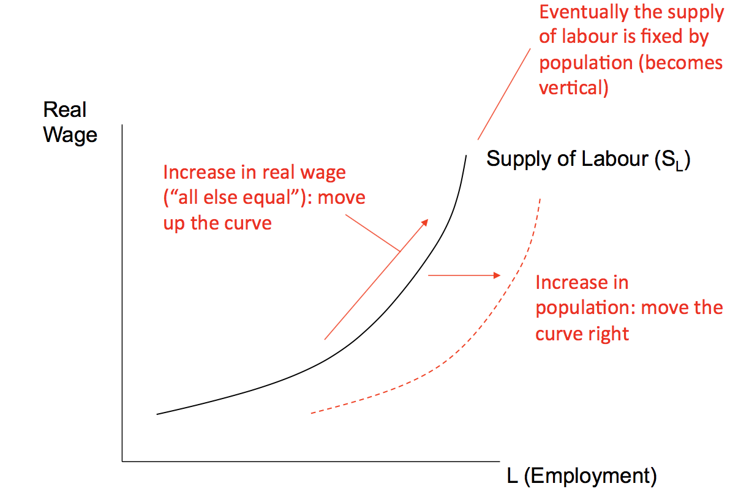

* The labour market consists of the supply of labour (willing workers) and the demand for labour (available jobs).

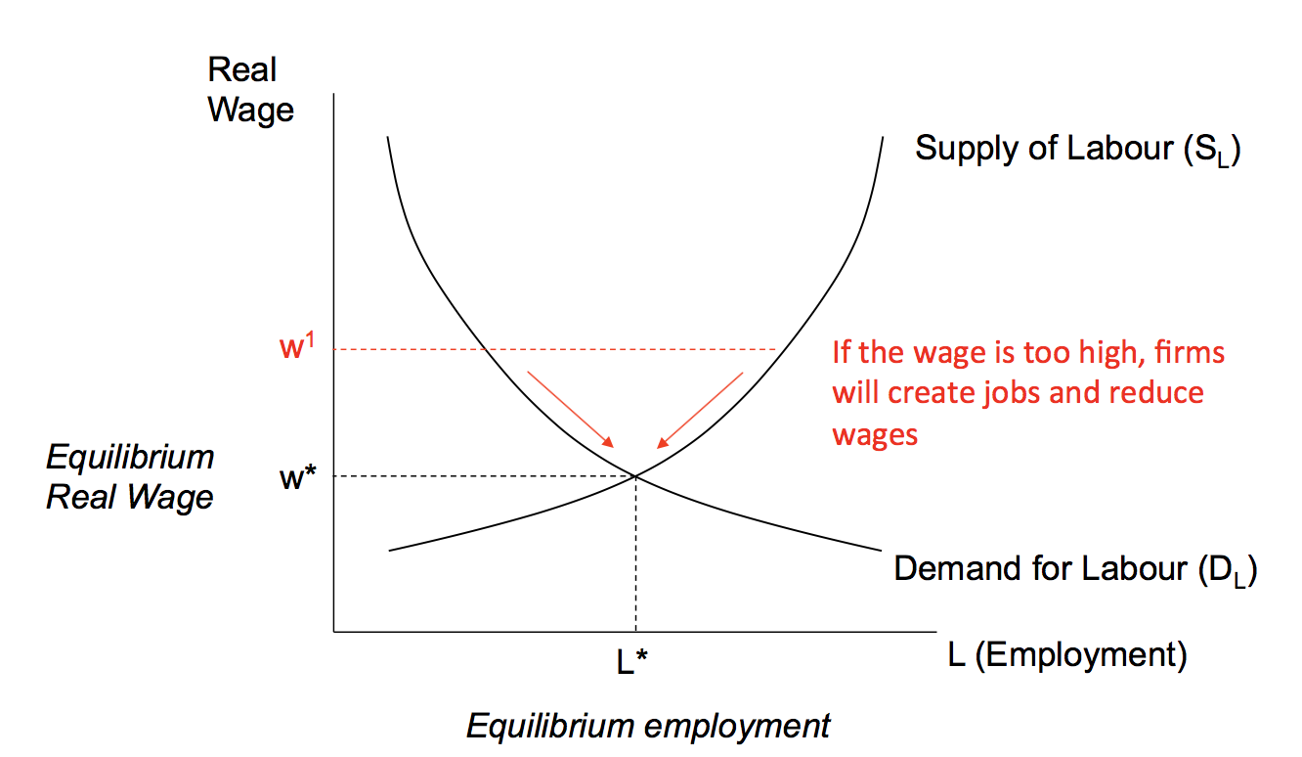

* Market forces bring the labour market into equilibrium.
* Q: If female labour force participation has increased so much, why hasn’t the real wage fallen since 1980s?  
  A: The increase in female labour force participation has increased the supply of labour. However, labour productivity has increase even more over this period, because of more capital and better technology per worker (increase in marginal benefit they obtained from hiring the worker), which has increased the demand for labour more than the supply, causing real wages to rise.

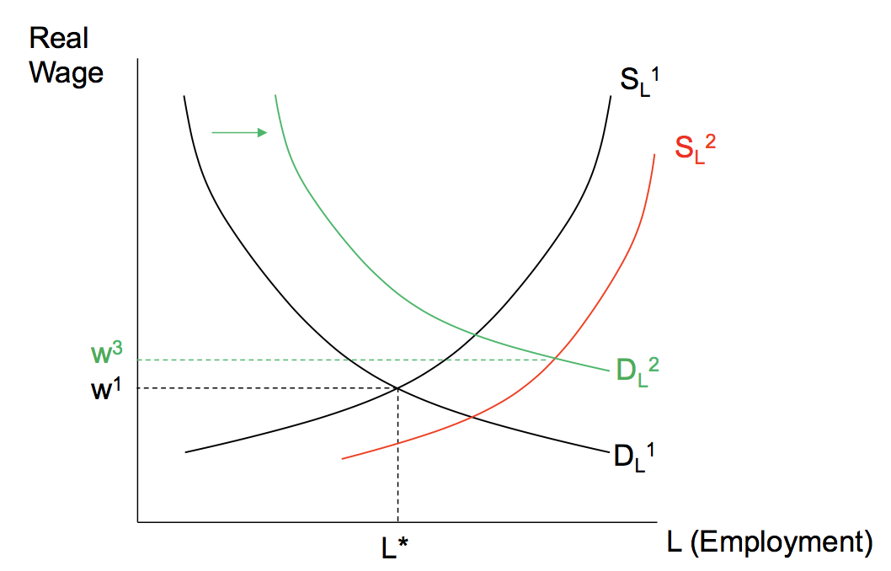

* Q2: Are Nigel Farage and Donald Trump right? Do immigrants steal jobs and reduce wages?

A2: If Sydney (population ~5 million) received 500 millions immigrants, the supply of labour would increase. But there aren’t a fixed number of jobs. New immigrants will also demand goods and services, increasing demand for labour. The net effect of immigration depends on the specifics of the labour market, and will differ based on the skills of the workforce.

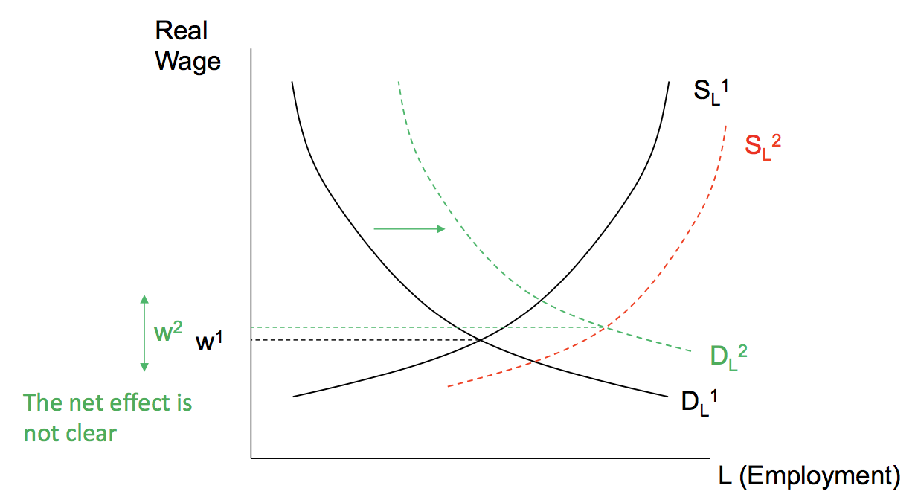

* Q3: Can technology growth affect the distribution of income?
* In general, technological advance has been a major source of improved productivity, which has driven up real wages.
* However, whether a particular technological innovation is good for a particular worker depends on what that innovation does for the value of his or her marginal product, and therefore his or her wage.
* The increased pace of technological change is biased toward skilled-based technological change – replacing unskilled labour and increasing the demand for labour with skills to use and maintain that technology.

A3: If technology complements high-skilled workers more than low-skilled workers, then yes. (Decrease the demand and real wages for low-skilled workers and increase the demand and real wages for high-skilled workers, which increases the inequality)

* However, any change in unemployment so far is voluntary. None of this can explain involuntary unemployment.

**Unemployment**

* Measuring unemployment:
* People who are 15 years old or over can be categorised into three categories:

1. Employed
2. Unemployed
3. Out of the labour force: those who did not work in paid employment and are not actively seeking employment.

* Every person in Australia over the age of 15 is either in or out of the labour force.
* Labour force definitions:

Labour force = employed + unemployed



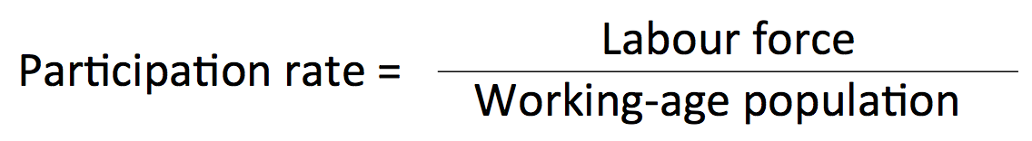

* Australia’s unemployment trends:

1. Both participation and employment rates grew over the 2000s, but have stagnated in recent years, while in recent years unemployment and underemployment have risen.
2. Australia’s unemployment rate is historically ~5%. It peaked during the great depression, and was low during the post WWII years.
3. Australia’s unemployment rate didn’t jump too much during the global financial crisis but has recently begun to rise, particularly in WA.

* Unemployment is very bad for the country and its economy:

1. Personal costs:

* Inability to meet financial obligations (eg. Mortgages/schools)
* Loss of skills and purpose
* Loss of self-esteem and depression
* Can lead to family problems

1. Economic costs:

* Under-utilisation of workforce
* Lower tax income
* Higher welfare payments
* Loss of skills and know-how

1. Social Costs:

* Crime
* Domestic violence
* Types of unemployment:

1. Frictional unemployment refers to the short-term unemployment associated with the process of worker searching for the right job. (Between jobs and current searching for another jobs) It can be seen from the number of unfilled job advertisements.
2. Structural unemployment refers to the long-term and chronic unemployment that exists when the skills or aspirations of workers are not matched to the jobs available in the economy. It can be the result of:

* A mismatch of skills demanded (including language and reliability) and job seeker’s skills (if any)
* High unemployment benefits which raise the opportunity cost of working
* Workplace discrimination
* Minimum wage laws and other government regulation of employment conditions --- cause the supply of labour to exceed the demand for labour. However, a minimum wage also redistributes income from capital to poorer workers, who are more likely to spend.

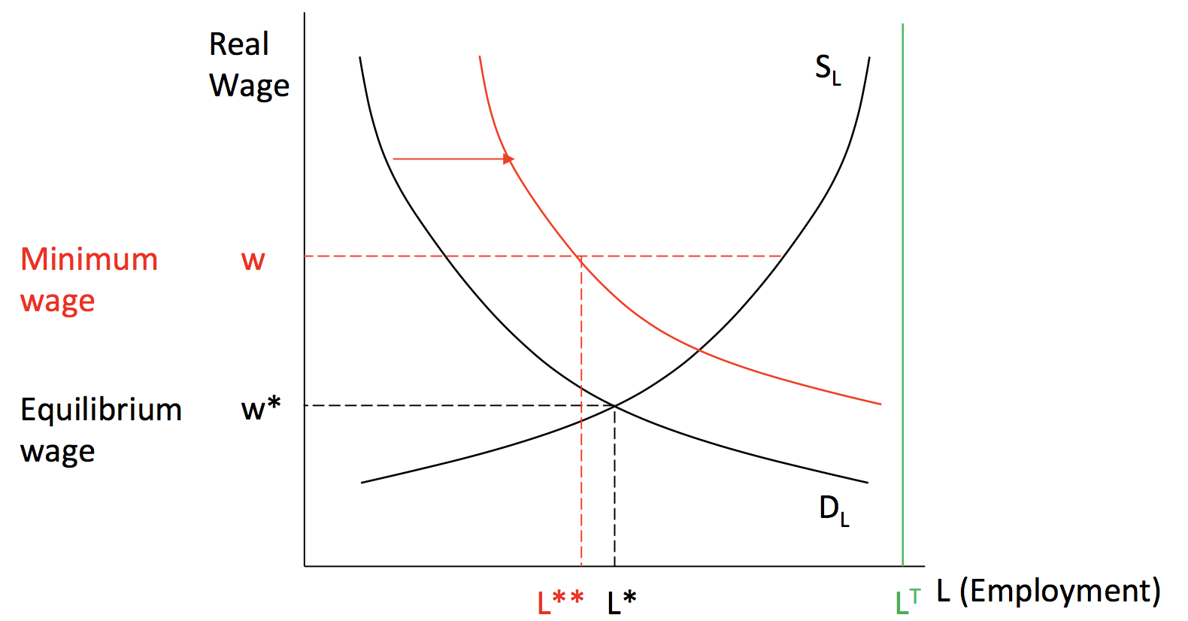

* People with low incomes have a higher “marginal propensity to consume”, ie. They are more likely to spend their income. Redistribution can stimulate the economy.
* Might cause economy to substitute from low skilled to higher-skilled jobs.
* People with low incomes have a higher marginal utility from an additional dollar, so aggregate welfare will also be higher.
* Health and safety regulations make it more expensive to hire workers (reduce labour demand), but makes them healthier (increases supply + demand)

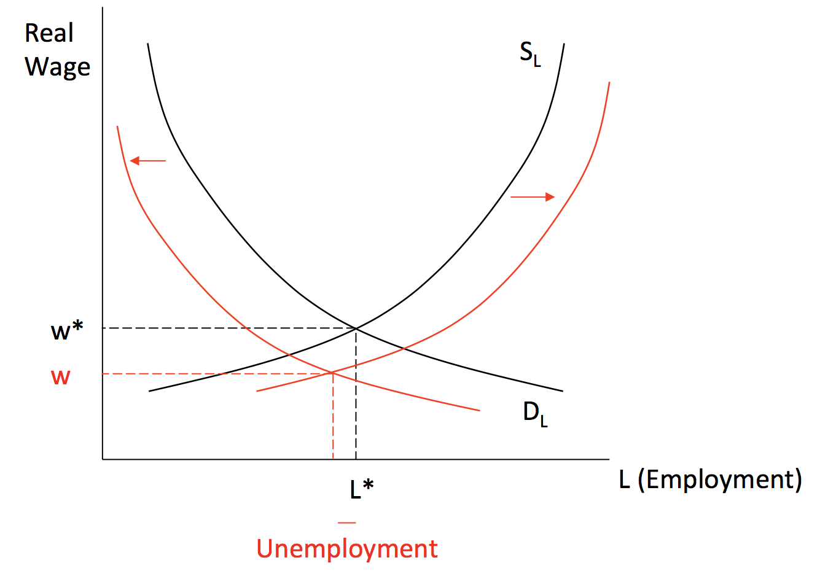

* Health and safety regulations increase the cost of each worker. (shift to the left)
* But, it increases productivity by preventing unnecessary injuries. (shift to the right)
* It also increases the health of the overall workforce, increasing L(employment)

1. Cyclical unemployment refers to the extra unemployment that occurs during periods of economic contraction and especially recessions. It can happen when:

* There is a fall in aggregate demand (and therefore labour demand)
* Sticky prices (Wages)

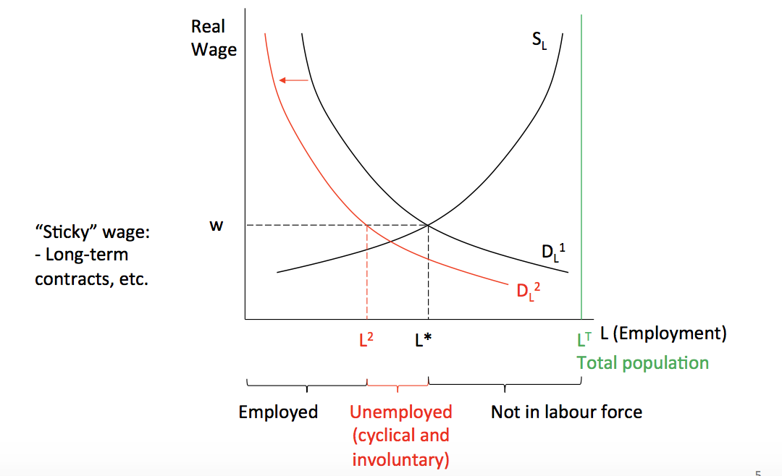

* Natural rate of unemployment:

1. Natural rate of unemployment = frictional + structural
2. Exists independently of whether the economy is in an expansion or contraction. The part of the total unemployment rate that is attributable to frictional and structural unemployment --- the unemployment rate that prevails when cyclical unemployment is zero.
3. Natural rate of unemployment (U*) occurs when neither a recessionary nor an expansionary gap exists:

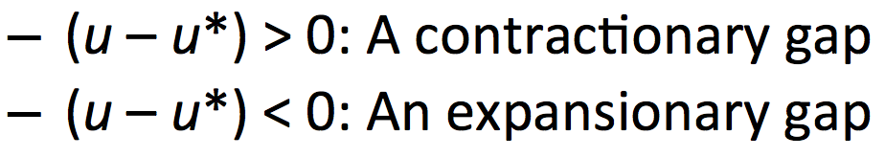

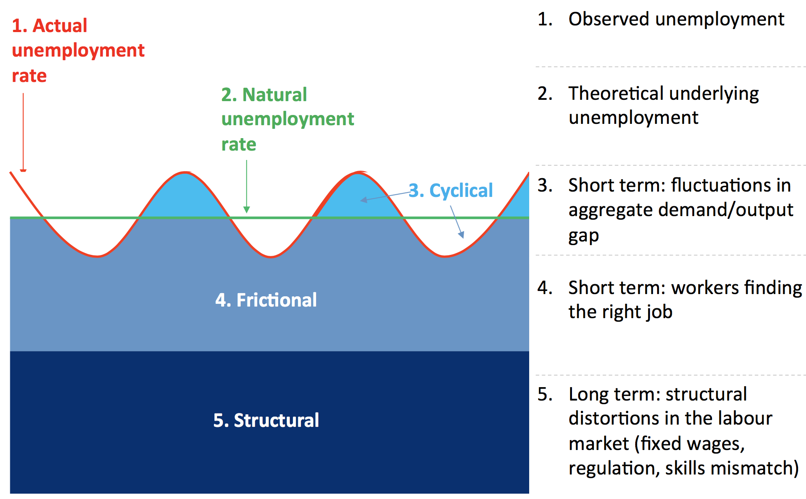

Questions:

3.1 How can the perfectly competitive model be used to understand trends in the labour market?

3.2 What have been the five major trends in the labour market in the post-war era?

3.3 What factors influence firm’s demand for labour?

3.4 What factors influence worker’s supply of labour?

3.5 What are the three different types of unemployment?

3.6 For what reasons do some countries find it difficult to achieve full employment?